**Project Design Phase-II**

**Data Flow Diagram & User Stories**

|  |  |
| --- | --- |
| Date | 31 January 2025 |
| Team ID | SWTID1743610409 |
| Project Name | Tune Trails |
| Maximum Marks | 4 Marks |

**Data Flow Diagrams:**

The Data Flow Diagram for **Tune Trail** illustrates how data moves through the system, from user interactions to music streaming and storage. Below is a simplified representation:

Standard)

**Example:**

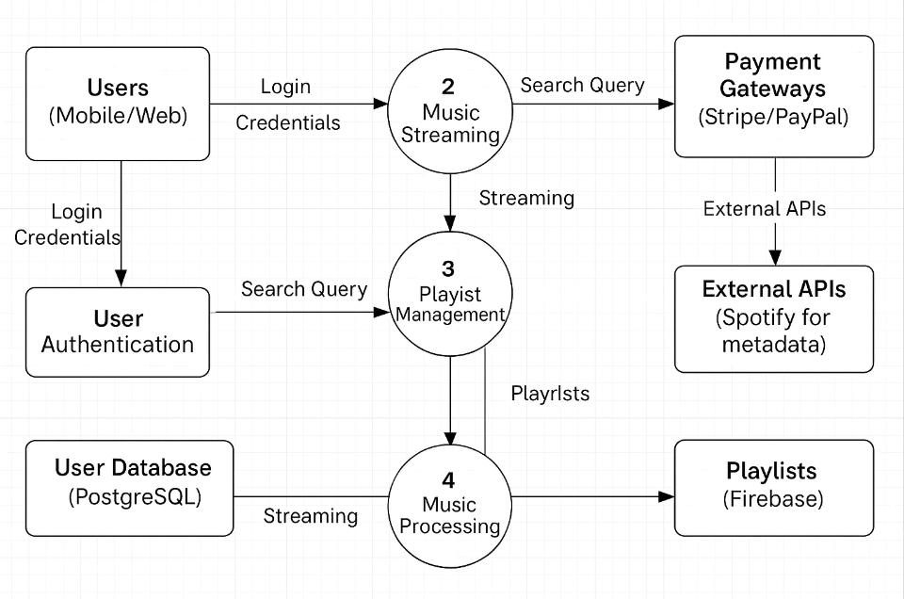

**User Stories**

Use the below template to list all the user stories for the product.

| **User Type** | **Functional Requirement (Epic)** | **User Story Number** | **User Story / Task** | **Acceptance criteria** | **Priority** | **Release** |
| --- | --- | --- | --- | --- | --- | --- |
| Customer (Mobile user) | Registration | USN-1 | As a user, I can register using my email and password to access the app. | I can log in and see the home screen. | High | Sprint-1 |
|  |  | USN-2 | As a user, I can register using my Google/Facebook account for faster access. | I can log in via social media and see my profile. | Medium | Sprint-2 |
|  | Authentication | USN-3 | As a user, I can log in using my credentials to access my playlists and preferences. | I can view my saved music and playlists. | High | Sprint-1 |
|  | Music Streaming | USN-4 | As a user, I can play, pause, skip, or repeat songs in the app. | Controls work seamlessly with no buffering. | High | Sprint-1 |
|  |  | USN-5 | As a user, I can search for songs by title, artist, or genre. | Results load in <2 seconds. | High | Sprint-1 |
|  | Playlist Management | USN-6 | As a user, I can create and edit playlists for my favorite songs. | Playlists save instantly and sync across devices. | Medium | Sprint-2 |
| Premium User | Subscription | USN-7 | As a premium user, I can download songs for offline listening. | Downloaded songs are playable offline. | High | Sprint-3 |
|  |  | USN-8 | As a premium user, I can enjoy ad-free music streaming. | No ads appear during playback. | High | Sprint-3 |
| Admin | Content Management | USN-9 | As an admin, I can upload and manage music metadata (artist, album, genre) | Metadata updates reflect in the app immediately. | Low | Sprint-4 |
|  |  | USN-10 | As an admin, I can monitor user activity and resolve reported issues. | Dashboard shows real-time analytics. | Medium | Sprint-4 |
|  |  |  |  |  |  |  |
|  |  |  |  |  |  |  |